Ocean&lake shader document
Universal renderer pipeline settings
I have changed two settings:
-Enabled opaque
-Enabled depth
*I also added the pipeline asset in the project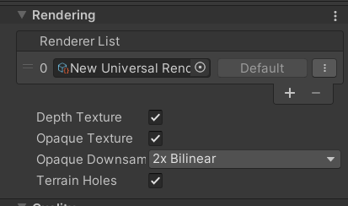
Ocean parameters:
Water color1 and 2: the colors of the ocean
Normal tile: the texture tile
Smoothness: how smooth the ocean
Normal speed: the speed of the texture moving on top of the ocean
WaveColor speed: the speed of the color that’s moving on the ocean
Wave strength: the height they go to and how strong they are
Foam speed: the speed of the foam texture changing
Foam distance: how far will the foam go from the object it's touching
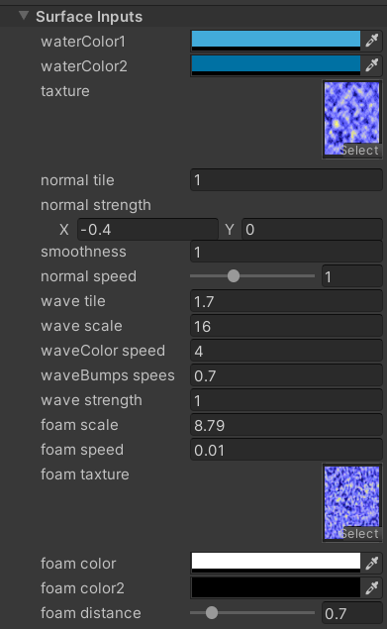
Lake parameters:
Shallow/deep colors: the colors of the lake
Water depth: the combination between those colors
Refraction speed: the speed of the texture(refraction) that's moving on top of the lake
Refraction scale: plays with the refraction texture
Refraction strength: how visible is the refraction
Foam scale: plays with the foam texture
Foam distance: how far will the foam go from the object it's touching
